Frankfurt Marathon 2018
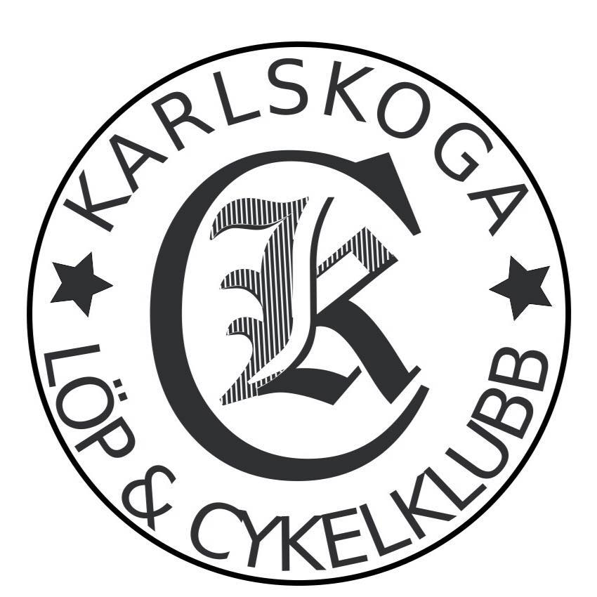

2018-10-28

115 (M35) – 490 (M) Fredrik Skogman -82 2:50.46
182 (M40) – 1054 (M) Torbjörn Björn -74 3:00.26 (PB)

Segertid: 2:06.37

